ASSIGNMENT NO. 10: Window Functions and Analytical Queries

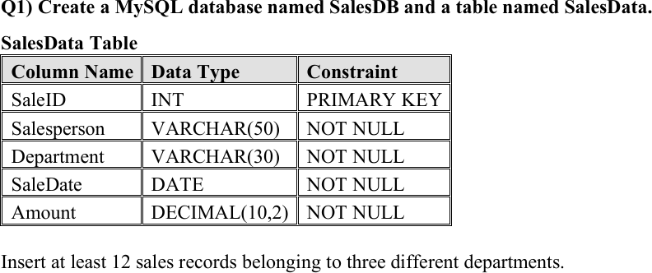

CREATE DATABASE SalesDB;

USE SalesDB;

CREATE TABLE SalesData ( SaleID INT PRIMARY KEY,
Salesperson VARCHAR(50) NOT NULL, Department VARCHAR(30) NOT NULL, SaleDate DATE NOT NULL,
Amount DECIMAL(10,2) NOT NULL
);

INSERT INTO SalesData
(SaleID, Salesperson, Department, SaleDate, Amount) VALUES
(1, 'Aarav Shah', 'Electronics', '2026-01-05', 50000.00),
(2, 'Priya Patil', 'Furniture', '2026-01-08', 40000.00),

(3, 'Rohan Desai', 'Electronics', '2026-01-12', 65000.00),
(4, 'Sneha Joshi', 'Furniture', '2026-01-15', 55000.00),
(5, 'Karan Mehta', 'Electronics', '2026-02-05', 65000.00),
(6, 'Meera Kulkarni', 'Furniture', '2026-02-10', 30000.00),
(7, 'Neha Shah', 'Clothing', '2026-02-12', 45000.00),
(8, 'Aman Verma', 'Clothing', '2026-02-18', 45000.00),
(9, 'Divya More', 'Electronics', '2026-03-03', 80000.00),
(10, 'Rahul Sharma', 'Furniture', '2026-03-06', 60000.00),
(11, 'Isha Nair', 'Clothing', '2026-03-10', 70000.00),
(12, 'Om Jadhav', 'Electronics', '2026-03-14', 55000.00);

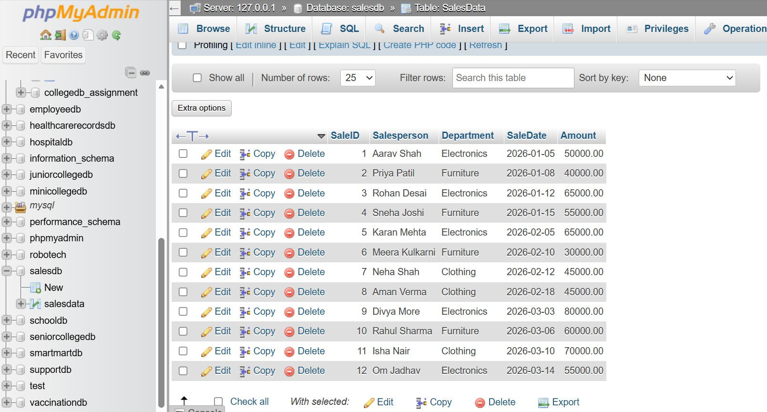

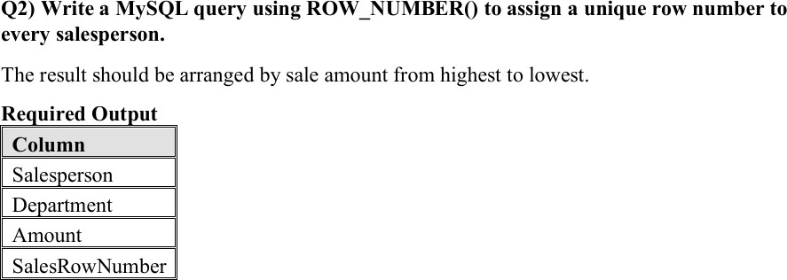

SELECT
Salesperson, Department, Amount,
ROW_NUMBER() OVER (
ORDER BY Amount DESC, SaleID ASC
) AS SalesRowNumber FROM SalesData;
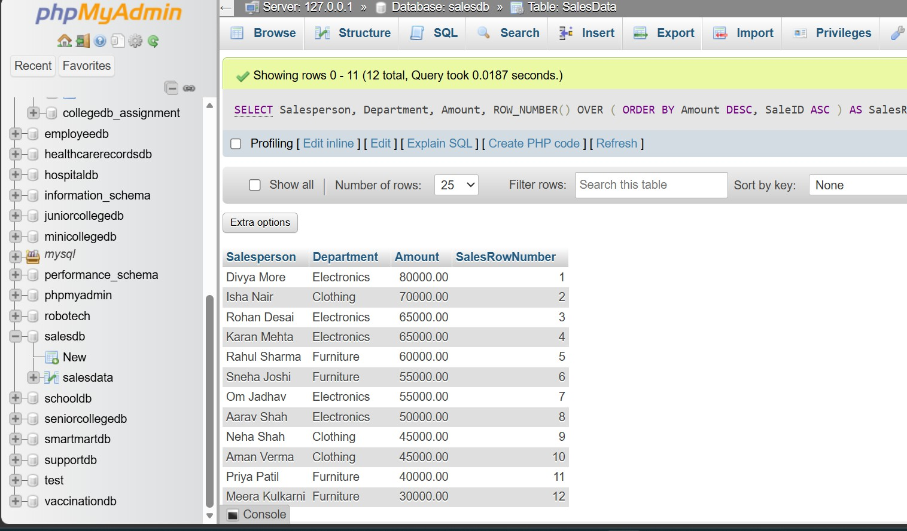

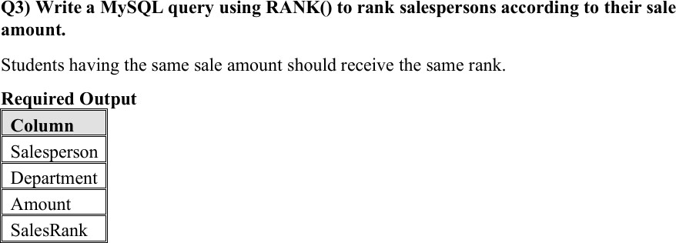

SELECT
Salesperson, Department, Amount, RANK() OVER (
ORDER BY Amount DESC
) AS SalesRank FROM SalesData;
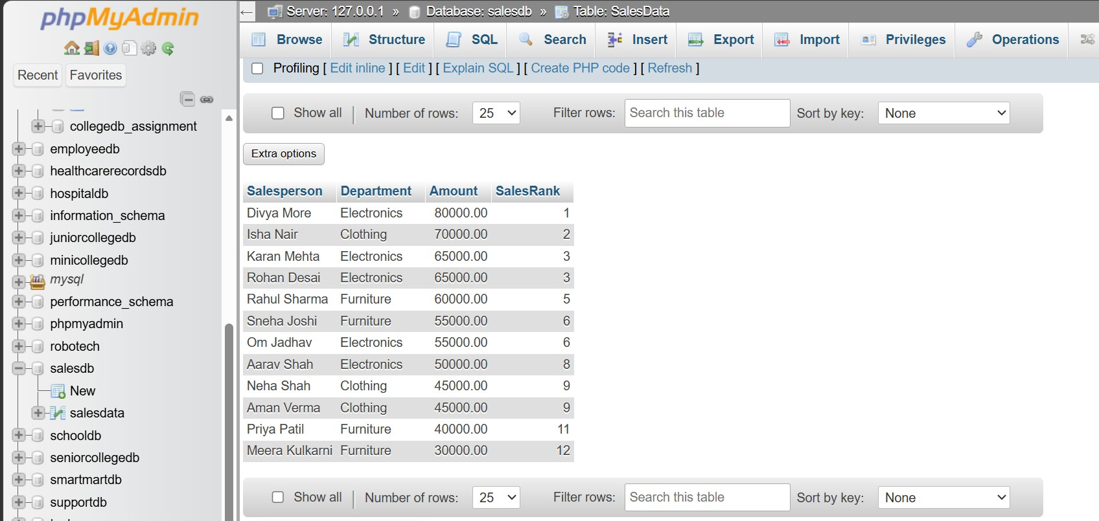

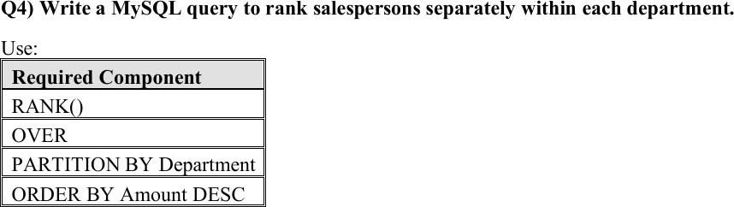

SELECT
Salesperson, Department, Amount, RANK() OVER (
PARTITION BY Department ORDER BY Amount DESC
) AS DepartmentRank FROM SalesData;
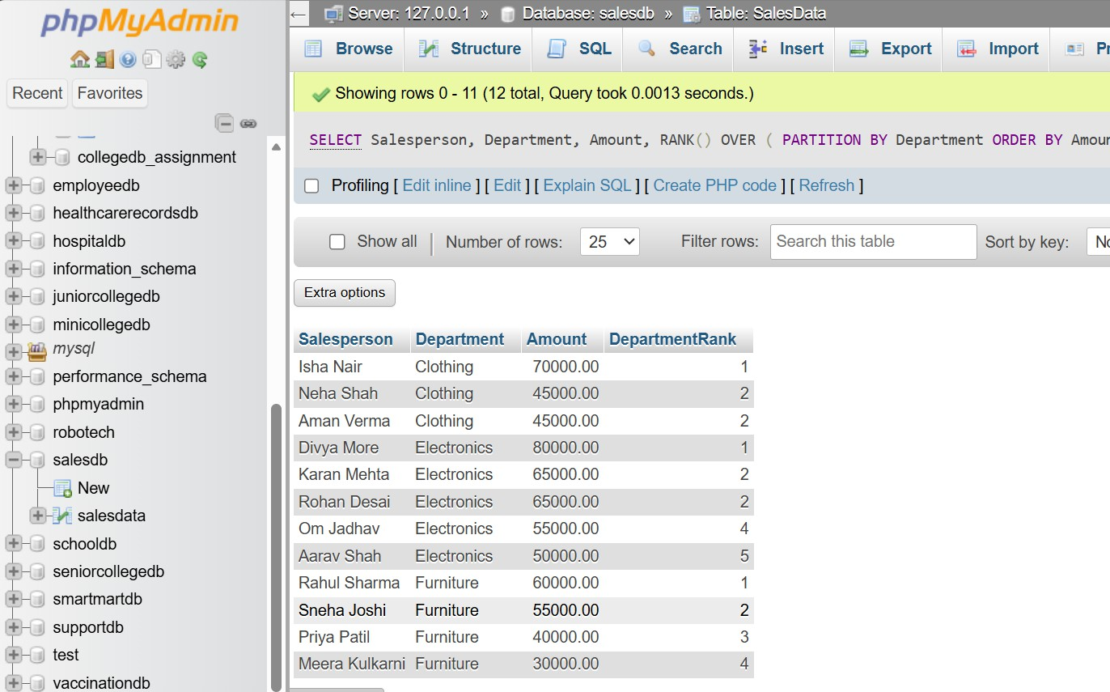

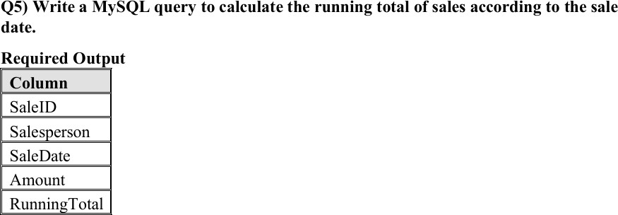

SELECT
SaleID, Salesperson, SaleDate, Amount,
SUM(Amount) OVER ( ORDER BY SaleDate, SaleID

ROWS BETWEEN UNBOUNDED PRECEDING AND CURRENT ROW
) AS RunningTotal FROM SalesData
ORDER BY SaleDate, SaleID;

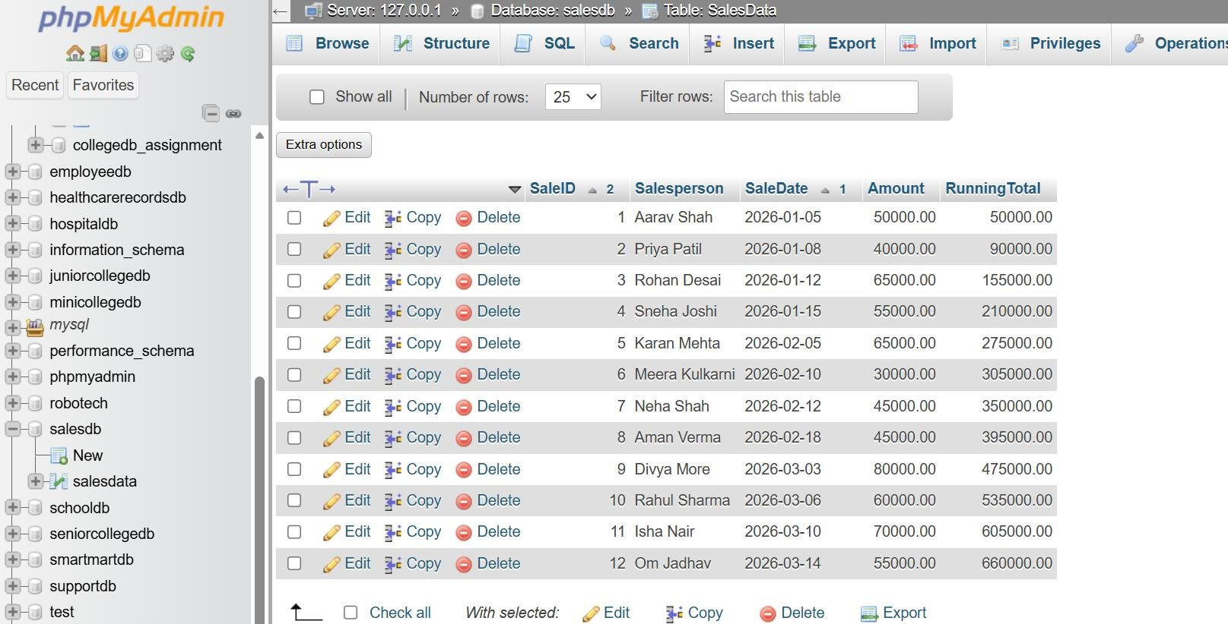

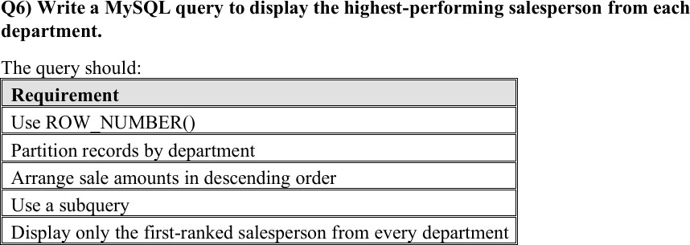

SELECT
Salesperson, Department, Amount

FROM ( SELECT
Salesperson, Department, Amount,
ROW_NUMBER() OVER (

PARTITION BY Department
ORDER BY Amount DESC, SaleID ASC
) AS DepartmentRowNumber FROM SalesData
) AS DepartmentSales
WHERE DepartmentRowNumber = 1;

